Pre-measurement letter to parents Spring & Summer Terms 2021

School Health Nurses
East Oxford Health Centre
Manzil Way
Cowley
OX4 1GE

01865 904225
9th June 2021

Height and weight checks for children in Reception and Year 6
Every year in England, school children in Reception and Year 6 have their height and weight checked at school as part of the National Child Measurement Programme. Height and weight measurements are used to calculate weight status. We collect this information because it is in the public interest to understand how many children are overweight, healthy weight or underweight. Your child’s class will take part in this year’s programme.

The checks are carried out by trained members of the school health nurse team. Children are measured fully clothed, except for their coats and shoes, in a private space away from other pupils. The programme will be delivered in a COVID-safe way, in line with the school and local authority’s safety control measures. This includes robust hand and respiratory hygiene and enhanced cleaning arrangements for the rooms and equipment used to measure your child’s height and weight as recommended in the national guidance for schools and healthcare.

The information we collect and what it is used for is listed below:
- your child’s date of measurement, sex and date of birth are used to calculate your child’s weight category
- your child’s name, date of birth and NHS Number (when available) are used to link your child’s measurements in Reception and Year 6. Other data sets may also be linked such as your child’s dental survey results or any visits to hospital they may have had. Linking your child’s information in this way helps us to understand how and why the weight status of children is changing, and how this affects children’s health
- your child’s ethnicity and address are used to help understand some of the reasons for the difference and changes in child weight across England
- your address is required to send you your child’s feedback letter. This will include your child’s measurements together with information about healthy eating, being active and related activities available in your area.
- your address is required to send you your child’s feedback letter. This will include your child’s measurements together with information about healthy eating, being active and related activities available in your area.

All the data collected is also used for improving health, care and services through research and planning. All this information is treated confidentially and held securely. No individual measurements will be given to school staff or other children.

How the data is used
The information collected from all schools in the area will be gathered together and held securely by Oxford Health NHS Foundation Trust and NHS Digital. We will store your child’s information as part of their local child health record on the NHS’s child health information database and share it with their GP if requested.

All the information collected about your child will be sent by us to NHS Digital. NHS Digital is responsible for collecting data and information about health and care so that this can be used to monitor and improve the care provided to people across England.

The information collected about your child will also be shared by NHS Digital with Public Health England but in a de-personalised form only. This means Public Health England will not be able to identify your child. Public Health England is responsible for working to protect and improve the nation’s health.

Both NHS Digital and Public Health England will use the information from the National Child Measurement Programme to better understand numbers and trends in child weight and body mass index (BMI). This helps with the planning of services to support healthy lifestyles in your area. No information will ever be published by NHS Digital or Public Health England that identifies your child.

De-personalised information from the National Child Measurement Programme may also be shared by NHS Digital with other organisations, such as universities. This is to help improve health, care and services through research and planning. This information cannot be used to identify your child, and NHS Digital only ever shares information for research with the approval of an independent group of experts.

Withdrawing your child from the National Child Measurement Programme
If you are happy for your child to be measured, you do not need to do anything.

If you do not want your child’s height and weight to be checked, or your child has a medical condition that affects their height or weight please let us know using the contact details provided below.
Your contact from the school health nurse team is:
Staff Name Gemma Ellis Mobile No 07826878768
Children will not be made to take part on the day if they do not want to.

Further information
Further information about the National Child Measurement Programme can be found at https://www.nhs.uk/live-well/healthy-weight/national-child-measurement-programme
Information and fun ideas to help your kids stay healthy can be found at
https://www.nhs.uk/change4life
Information about how we Oxford Health collect and use information can be found at www.oxfordhealth.nhs.uk/privacy/

Information about how NHS Digital and Public Health England collect and use information can be found at https://digital.nhs.uk/about-nhs-digital/our-work/keeping-patient-data-safe/how-we-look-after-your-health-and-care-information and https://www.gov.uk/government/organisations/public-health-england/about/personal-information-charter

Information about the organisations NHS Digital has shared information from the National Child Measurement Programme can be found at https://digital.nhs.uk/services/national-child-measurement-programme

How your child’s data is collected and processed as part of the National Child Measurement Programme (NCMP)
Local authorities have a legal duty to collect the NCMP data. They do this by following guidance from Public Health England. Local authorities are responsible for making decisions on how the data is collected and for making sure it is protected. Local NCMP service providers are contracted to carry this out; this might be through the school nursing team working in schools or a local healthcare provider. The team collecting the data enter it into the NCMP IT system, which is provided by NHS Digital. The data may also be entered into a local child health information system. Your local authority is responsible for sending the data to NHS Digital. NHS Digital and Public Health England are jointly responsible for the data held at a national level. Your local authority is responsible for the data held locally.
The chart below displays what happens to your child’s data as part of the NCMP.
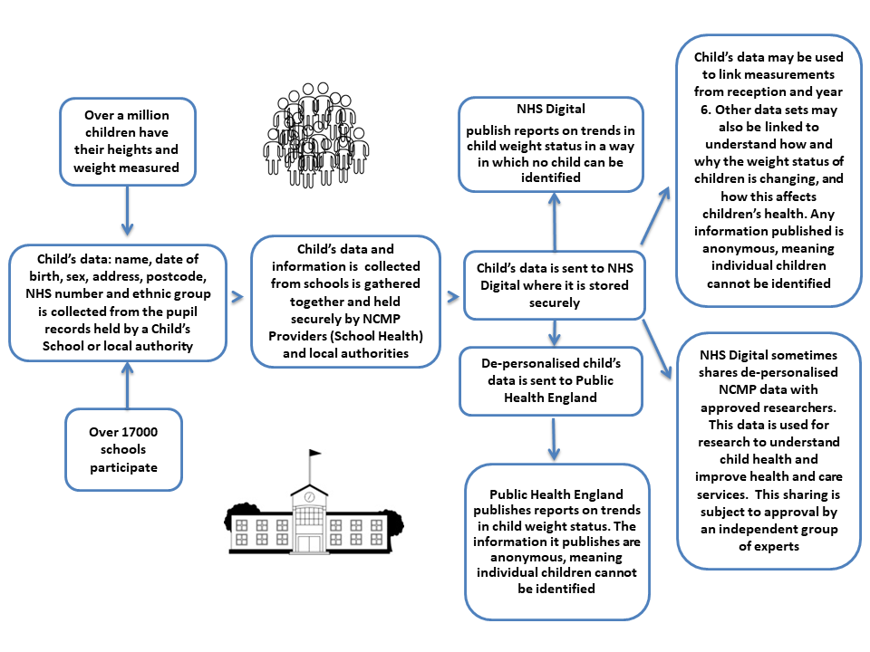
Yours faithfully,

Dr Ansaf Azhar Emma Leaver
Director of Public Health Director of Children’s Services
Oxfordshire County Council Oxford Health NHS Foundation Trust

